How to determine the value of LDR pos. 17 when a brief record is created from a purchase request | 

Yoel Kortick
Senior Librarian

Question
Hi. When a purchase request is made and there is no match for it in Alma a new record is created with an LDR which has a hardcoded value in position 17. How can we change the default value of LDR position 17?

Short Answer:
Change it in the default cataloging template

Full (recommended) answer:

ONE
Let’s answer this with a real life example:
An end user creates a purchase request in Primo

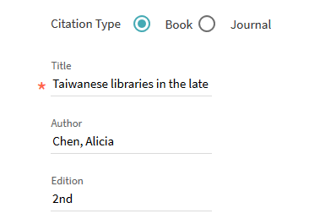





TWO
A bibliographic record is created in Alma (because there was no match on an existing record).
See that pos. 17 of the LDR has #.
See also that there are these other defaults:

040 has $$b eng $$e rda ?
082 has $$2 23
300 has $$a pages : $$b illustrations ; $$c cm. ?

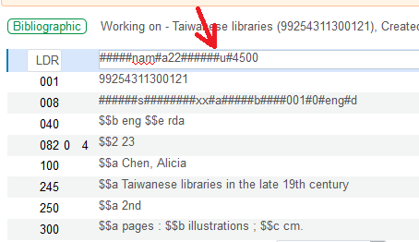

THREE
The defaults come from the default cataloging template for the MARC type of the record which is created, in this case MARC21:

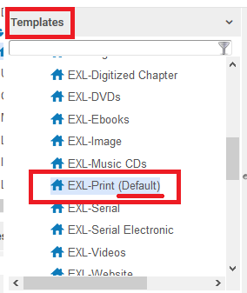

FOUR
Note the contents of the template (including pos. 17 of LDR as “#”):

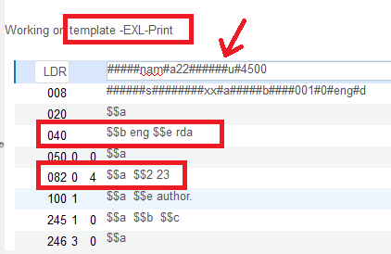

FIVE

Now in the default template we change LDR pos. 17 from “#” to “5” and save the template

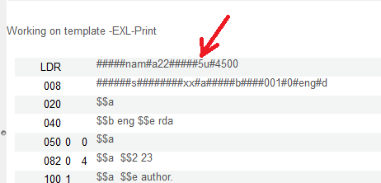

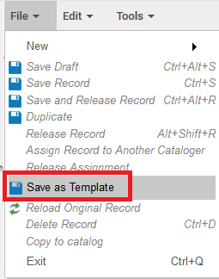

SIX

Now again we create a new purchase request in Primo, which will not match a record in Alma

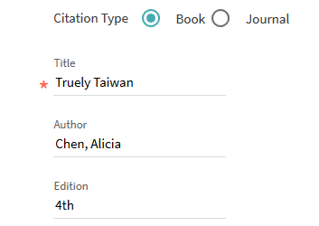

SEVEN

Check the record in Alma and see that LDR position 17 is now “5”:

